**SMART PROJECT MANAGEMENT SYSTEM**

**2021-234**

Project Status Document 2

**Navanjana E.H.D.T.D.**

**IT18003642**

BSc (Hons) in Information Technology

Specializing in Information Technology

Department of Information Technology

Sri Lanka Institute of Information Technology

Sri Lanka

November 2021

Table of Contents

1. Microsoft Teams chats & Meetings i

Figure 1.1 – Meeting history i

Figure 1.2 – Progress Presentation 2 i

Figure 1.3 – Meeting screenshot 1 ii

Figure 1.4 – Meeting screenshot 2 (Conference blind review results discussion) ii

Figure 1.5 – Meeting screenshot 3 (Conference blind review results discussion) iii

Figure 1.6 – Meeting screenshot 4 (Demo testing meeting) iii

2. Microsoft Teams project planner iv

Figure 2.1 – MS Project planner screenshot 1 iv

Figure 2.2 – MS Project planner screenshot 2 iv

3. GitLab Reports v

Figure 3.1 - Repository v

Figure 3.2 – Contribution v

Figure 3.3 – Contribution graph vi

Figure 3.4 – Programming Languages Chart vi

# 1. Microsoft Teams chats & Meetings

## Figure 1.1 – Meeting history

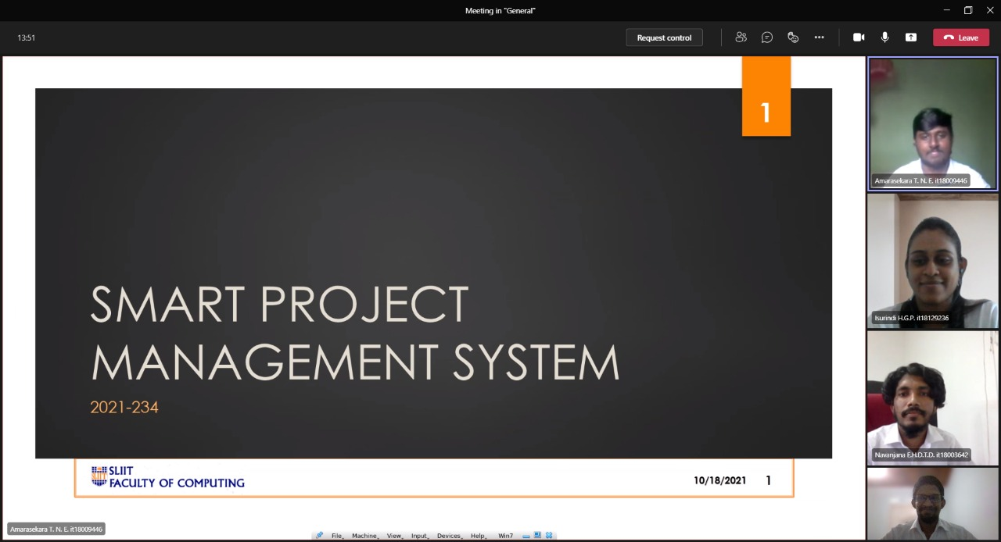

## Figure 1.2 – Progress Presentation 2

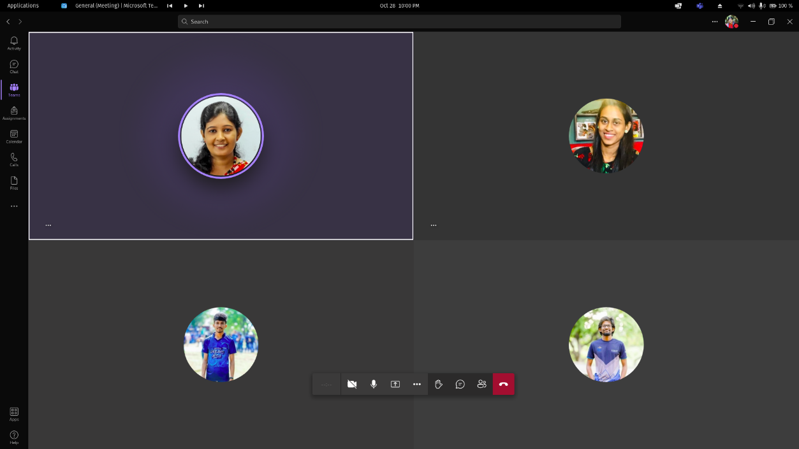

## Figure 1.3 – Meeting screenshot 1

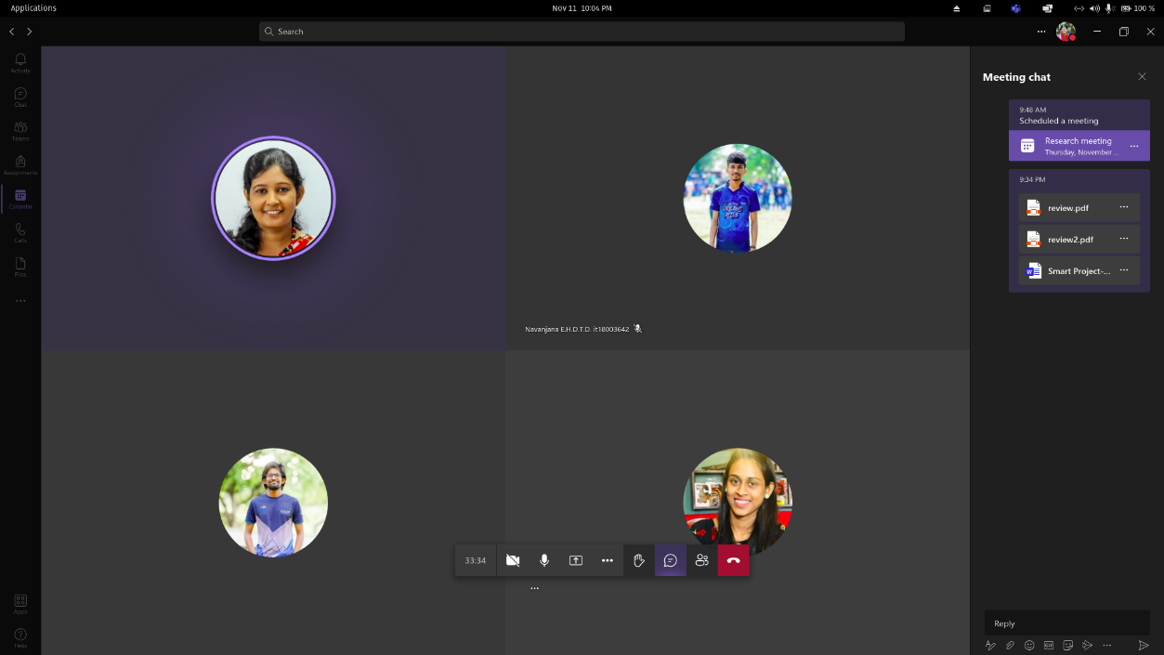

## Figure 1.4 – Meeting screenshot 2 (Conference blind review results discussion)

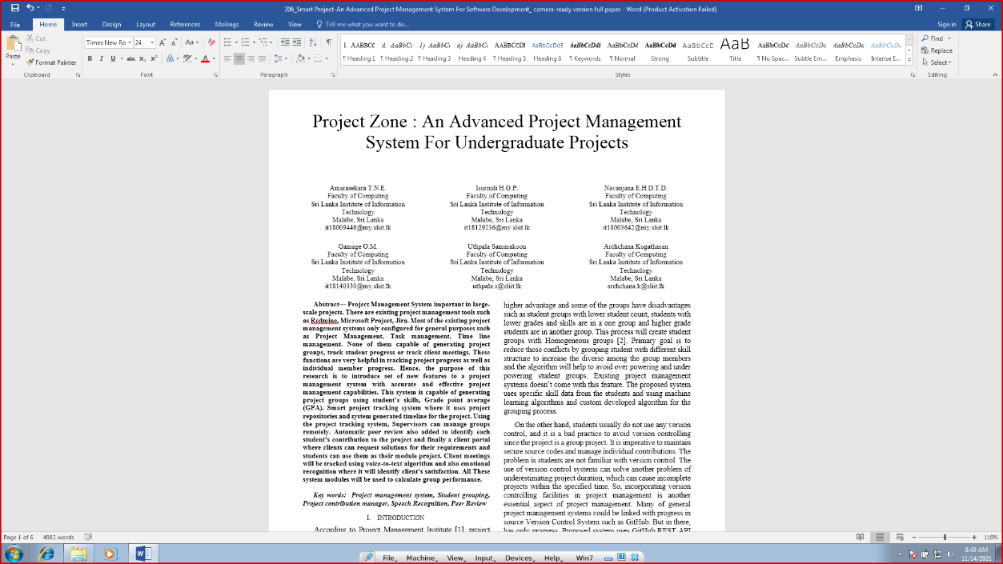

Figure 1.5 – Meeting screenshot 3 (Conference blind review results discussion)

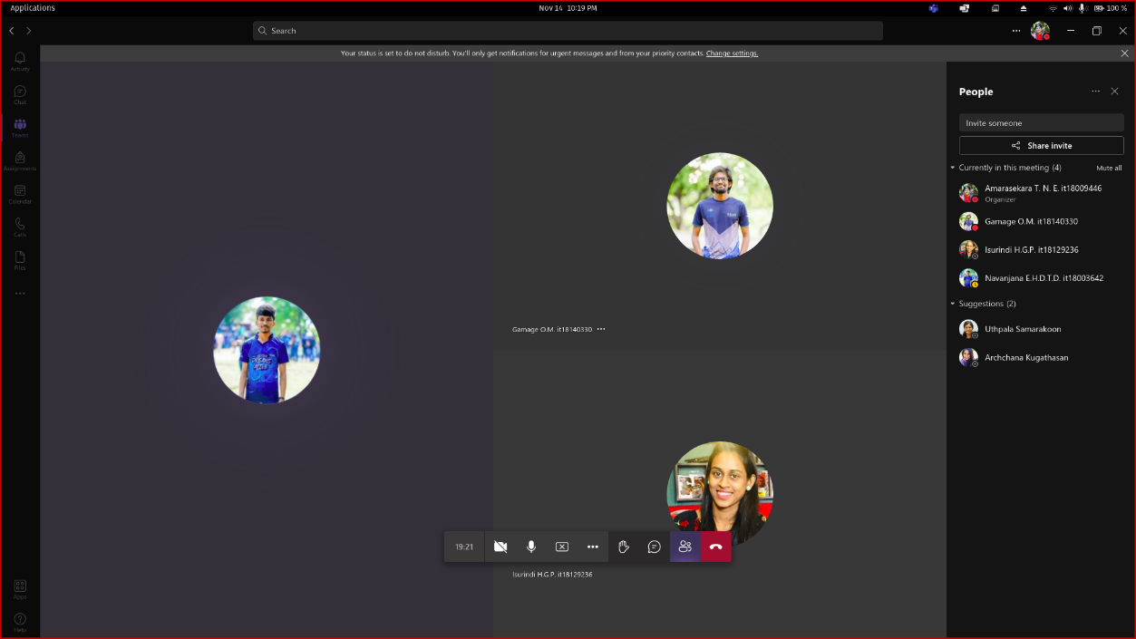

Figure 1.6 – Meeting screenshot 4 (Demo testing meeting)

# 2. Microsoft Teams project planner

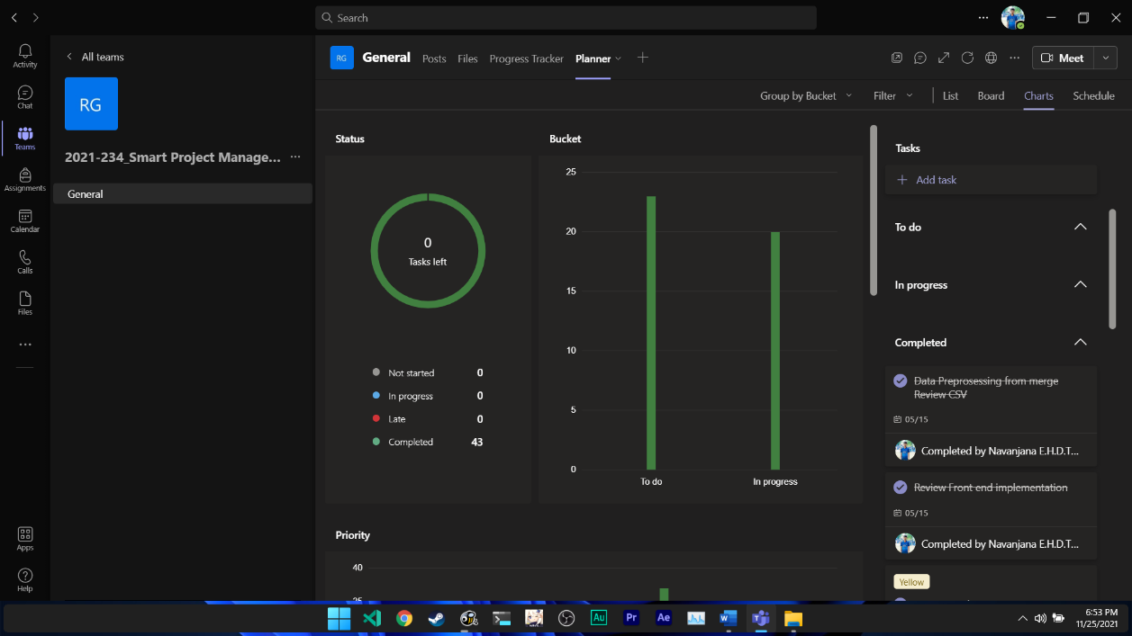

## Figure 2.1 – MS Project planner screenshot 1

## Figure 2.2 – MS Project planner screenshot 2

# 3. GitLab Reports

## Figure 3.1 - Repository

## Figure 3.2 – Contribution

## Figure 3.3 – Contribution graph

## Figure 3.4 – Programming Languages Chart